The most dangerous species “powdery Mildew’ is a member of which group of fungi?
A. Basidiomycota
B. Ascomycota
C. Zygomycota
D. Deuteromycota
ANSWER: B

Which of the following is a very large group of about 30,000 named species?
A. Basidiomycota
B. Ascomycota
C. Zygomycota
D. Deuteromycota
ANSWER: B

The reproductive structure of Ascomycota is:
A. Zygospore
B. Asci
C. Basidium
D. Aplanospore
ANSWER: B

The __________hyphae are the results of mating between two genetically distinct monokaryons with different mating types.
A. Dikaryotic
B. Monokaryotic
C. Septate
D. Non-septate
ANSWER: A

The method of asexual reproduction in Ascomycota is by:
A. Fission
B. Conidia
C. Fermentation
D. Budding
ANSWER: B

This is not a member of Ascomycota:
A. Yeast
B. Mushrooms
C. Saccharomyces
D. Candida
ANSWER: B
Mucor and Rhizopus belong to:
A. Zygomycota
B. Basidiomycota
C. Ascomycota
D. Deuteromycota
ANSWER: A

Which of the following is the smallest of four groups of fungi?
A. Zygomycota
B. Ascomycota
C. Basidiomycota
D. Deuteromycota
ANSWER: A

Which of the following belongs to Zygomycota?
A. Neurospora
B. Bread molds
C. Yeast
D. Candida
ANSWER: B

The thick-walled resting cell of certain fungi and algae, arising from the fusion of two gametangia is called:
A. Spore
B. Aplanospore
C. Conidia
D. Zygospore
ANSWER: D
Which group have about 16,000 named species?
A. Basidiomycota
B. Ascomycota
C. Zygomycota
D. Deuteromycota
ANSWER: A

This is not a member of Basidiomycota:
A. Jelly Fungi
B. Puffballs
C. Mushrooms
D. Neurospora
ANSWER: D

Reproductive structure of Basidiomycota is:
A. Asci
B. Zygospore
C. Aplanospore
D. Basidium
ANSWER: D

The basidiospores are borne at the end of basidium on slender projections called:
A. Sterigmata
B. Stomata
C. Conidia
D. Sori
ANSWER: A
The only process responsible for the genetic variation in Deuteromycota is:
A. Parasexuality
B. Conjugation
C. Crossing over
D. Synapsis
ANSWER: A

The first antibiotic was extracted from the member of ____ class.
A. Basidiomycota
B. Deuteromycota
C. Ascomycota
D. Zygomycota
ANSWER: B

Citric acid is produced commercially by the members of ____ group.
A. Basidiomycota
B. Deuteromycota
C. Ascomycota
D. Zygomycota
ANSWER: B
________is the association in which both the partners are benefitted
A. Commensalism
B. Parasitism
C. Mutualism
D. Amensalism
ANSWER: C
The mutualistic symbiotic association formed by the fungi include:
A. Lichens
B. Mycorrhizae
C. Both A and B
D. None of these
ANSWER: C
Which of the following is an association between a fungus, a cyanobacterium or green alga:
A. Mycorrhizae
B. Barnacles
C. Lichen
D. Cattle Egrets
ANSWER: C
The body of a lichen has _____ layers
A. No
B. 1
C. 2
D. 3
ANSWER: D
The _____is thin and tough which consists of fungal hyphae
A. Upper layer
B. Middle layer
C. Bottom layer
D. Matrix
ANSWER: A
The __________consists of fungal hyphae interwoven with photosynthetic cell
A. Upper layer
B. Middle layer
C. Bottom layer
D. Matrix
ANSWER: B
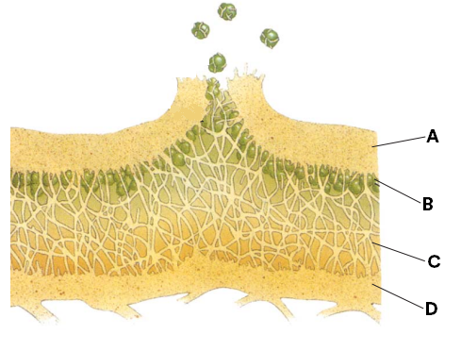
What does C represent in the given diagram?
A. Bottom layer (fungal hyphae)
B. Loosely woven hyphae
C. Fungal hyphae interwoven with phototroph
D. Surface layer (fungal hyphae)
ANSWER: B

What does D represent in the given diagram?
A. Bottom layer (fungal hyphae)
B. Loosely woven hyphae
C. Fungal hyphae interwoven with phototroph
D. Surface layer (fungal hyphae)
ANSWER: A
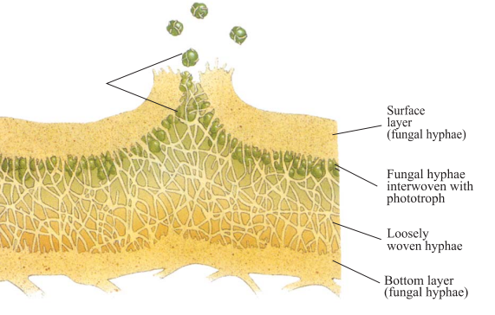
Observe the diagram and identify the structure:
A. Mycorrhizae
B. A cross-section of lichen
C. A cross-section of endomycorrhizae
D. A cross-section of ectomycorrhizae
ANSWER: B

What does A represent in the given diagram?
A. Bottom layer (fungal hyphae)
B. Loosely woven hyphae
C. Fungal hyphae interwoven with phototroph
D. Surface layer (fungal hyphae)
ANSWER: D

What does B represent in the given diagram?
A. Bottom layer (fungal hyphae)
B. Loosely woven hyphae
C. Fungal hyphae interwoven with phototroph
D. Surface layer (fungal hyphae)
ANSWER: C
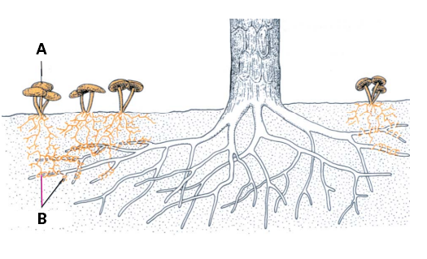
Observe the diagram and identify the association:
A. Mycorrhizae
B. Barnacles
C. Lichen
D. Cattle Egrets
ANSWER: A

What does A represent in the given diagram?
A. Bottom layer (fungal hyphae)
B. Loosely woven hyphae
C. Mushroom fruiting body
D. Mycorrhizae
ANSWER: C
A ____________ is a symbiotic association between a fungus and a plant
A. Mycorrhizae
B. Barnacles
C. Lichen
D. Cattle Egrets
ANSWER: A
The term mycorrhiza refers to the role of the fungus in the
A. Plant's rhizosphere, its root system
B. Plant’s centre
C. Plant’s stem system
D. Vascular bundle of plant
ANSWER: A

